

NOVAC TECHNOLOGY SOLUTIONS

User Manual

Document Version No.: 1.00

Revision History
Version No | Reason For Changes | Author | Approver
0.01 | Draft | Anurag Kumar
1.00 | Reviewed & Approved the User Manual | Anurag Kumar | NIJANTHAN PL

Table of Contents
1. Introduction 4

2. Data privacy Clause 4

Introduction

As per the requirement, System should mandate the data privacy warrantees for Motor and Fire Product.
- Guidelines, circulars, instructions and directions released from time to time by Philippines Insurance council.

Functional Overview

In the current system, data privacy warranties are optional. Now the system is required to mandate the data privacy warranties for Motor and Fire Product

Data privacy Clause

- System should mandate the data privacy warranties for Motor and Fire Product. System should follow the existing wordings of data privacy warranties.
Click on the Proposal Entry Screen, Add a new proposal or edit a record from the dashboard. System will display the Data Privacy Clause under in Motor Proposal.

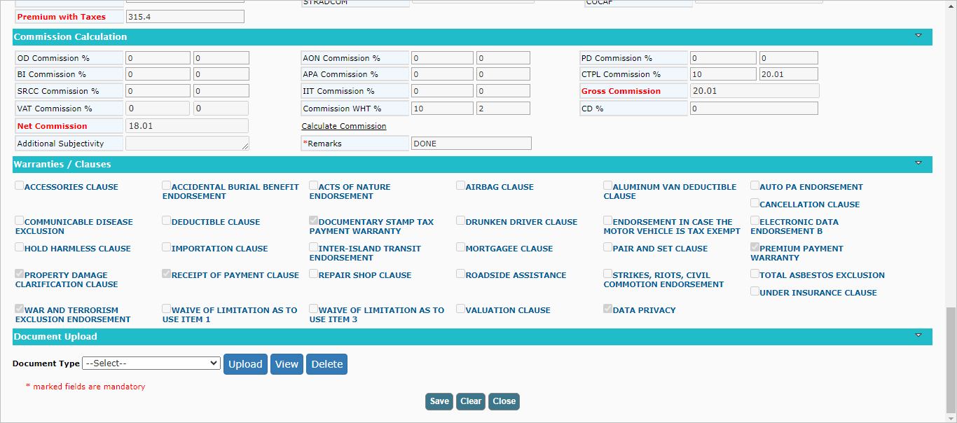

Click on the Fire Proposal Screen, Add a new proposal or edit a record from the dashboard. System will display the Data Privacy Clause under in Fire Proposal.
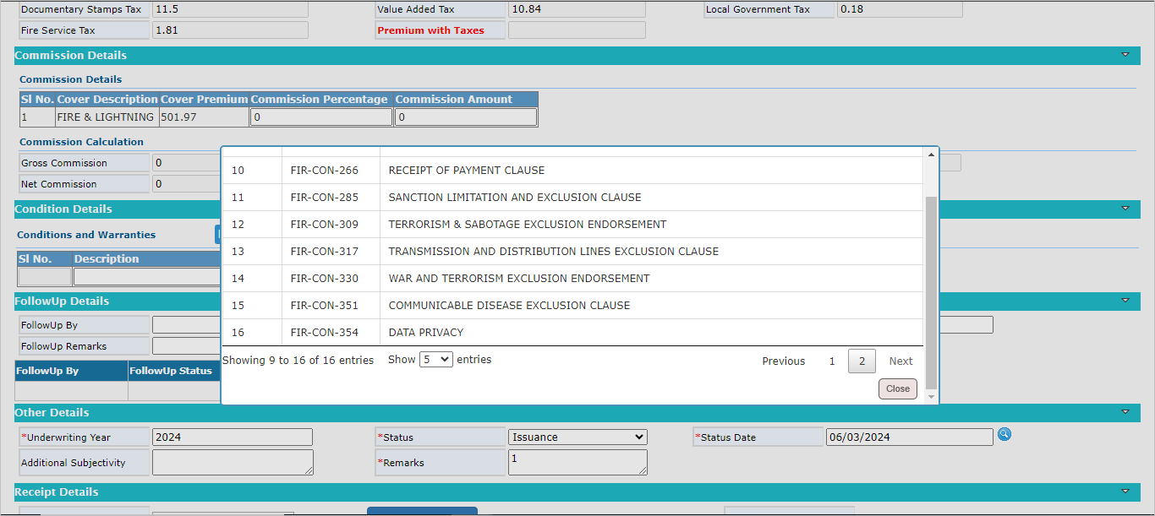

Note: The Data Privacy Wording will display in the policy Schedule.

Click on close button to close the window.

